Juan Sebastian Gultom

Moh Erwin Septianto

Raisa Imani Sani

Muhamad Rausyan Fikri, S.Si, M.Eng, MIEEE, MAIAA.

Data Structure and Algorithm (COMP2424-A)

November 10st, 2021

Proposal Final Exam

Library Management System

A. Introduction

Library Management System or LMS is an automated library system. This system helps librarians and readers to provide information on any book present in the library. It also keeps a track of books published, given in return, and added to the library.

As a student, through this project we want to challenge ourselves to create a simple library management system by using our knowledge we got from the data structures and algorithms course.

1. How it works

Our program is purpose on creating simple database system which can store the user data, modify, and show list of the book, borrow/return book, and late detection of book return. On to make it clearer, we are dividing the project into three parts: login, student login portal, and librarian portal.

Firstly, we are creating the login. This program helps as bridge to decide whether the users are librarian or student. The program starts with show login interface, which display input field to enter Student ID. It will check whether the login information is registered in databases. If it is not, then it will show error” You’re not registered. Please contact to librarian for further information”. When the user passes the login, the program will decide the user is librarian or not by checking the information login from user input. If the user is student, it will bring into student portal. If it’s the librarian, it will bring into librarian portal.

On creating the login, we use software called “Microsoft Visual Basic 6.0” that works as GUI tools on creating executable file (.exe). The exe file will connect as bridge and after the user success login, this program will atomically close and open specified program.

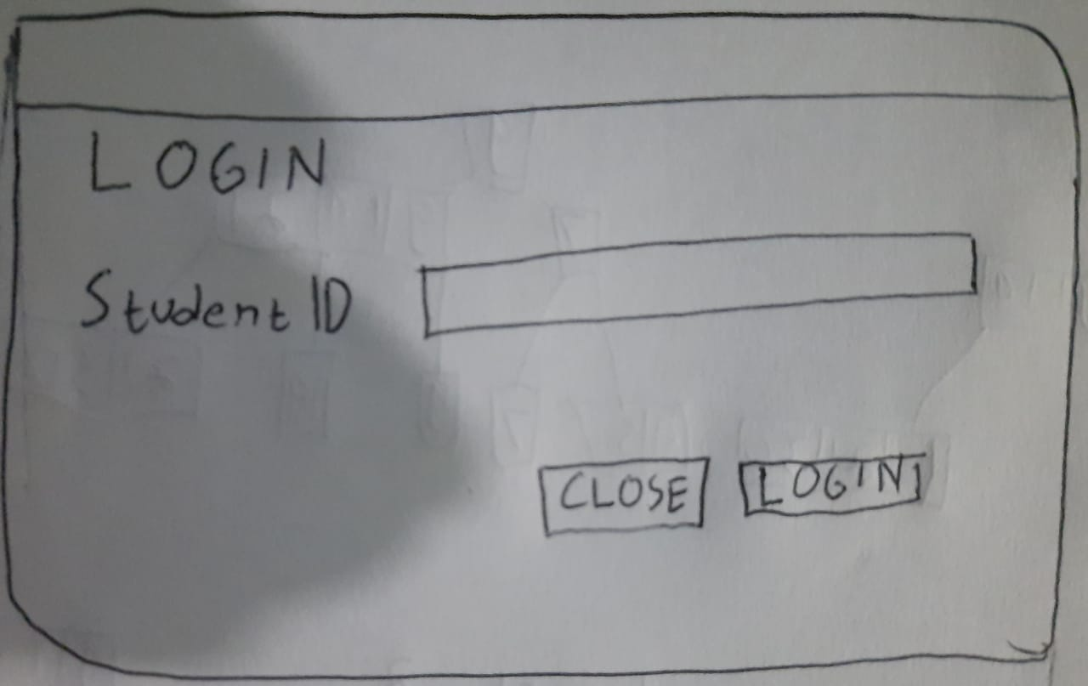

Figure This is an illustration of what the program will looks like.

The second program is student portal. When the users are student, the program login will automatically open student portal program (.exe). The program will have some feature such as view booklist, borrow book, return the book, and inquiry book. This program will read the list of the book from databases book. For history of return/borrow book will be recorded in databases history. It can give information about penalties if student return the book late. Creating this program will require to use hashing and stack. This method may be subject to change, but we will try to maximize use material which we gain after mid-exam.

Figure This is a preview of what the booklist will looks like.

Figure Kind of information(data) from databases which relate to the book.

Figure Kind of information(data) from databases which relate to the student.

The second program is librarian portal. This program only can access by librarian to view booklist, search book, modify/add book, check issue and resolved issue of book’s late, change category, and add/modify student data from LMS databases. To creating the program, we plan to use tree, hashing, binary search, sort. This method may be subject to change, but we will try to maximize use material which we gain after mid-exam.

Figure Kind of information(data) from databases which relate to the librarian.

Our library data is taken from internet, for example name of book and year published, with some changes to match our program. This simple program requires advance C++ with CRUD (Create, Read, Update, Delete) file technique, GUI integration, and save the record of program into standard text document (.txt). We haven't decided whether to use .txt or .csv for create databases.

C. Work distribution

Our group consists of three members, Juan Sebastian Gultom, Moh. Erwin Septianto, and Raisa Imani Sani. Juan is going to handle the development of interface. On doing this task, Juan focuses on designing the user interface and user experience. He also focuses on making sure that the database program connected to our program. On the other hand, Raisa is going to focus on developing librarian portal. This system will use some techniques we have learned in the class, such as hashing, stack, tree etc. For Erwin, in the early stages of development, he creates a flowchart & algorithm notation of how this system works. By using that, we can imagine how the system works and what we should do to make the system is better. On the middle of development, Erwin will handle the database of program, include CRUD in program, and developing student portal. This work structure will not always be the same; we will collaborate to assist each other, and we gain better understanding on how it works.